**DTA Wind Tunnel:**

**Assembly:** 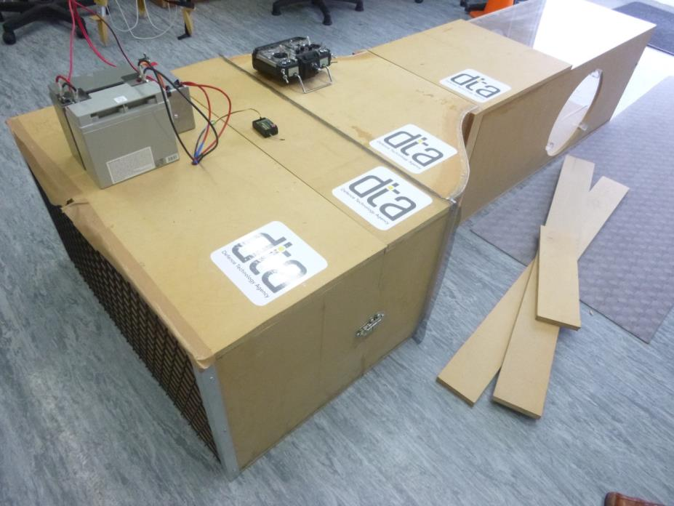

The wind tunnel is made up of 4 sections, labelled ‘A’ – ‘D’. Arrows are drawn on each section showing how they interface (i.e. “To B” etc). When connecting the sections some tape may be required between sections ‘C’ and ‘D’ inside the tunnel to seal any gaps. Note that the honeycomb and fabric in section ‘B’ are fragile to be careful not to damage it.

The wind tunnel is powered by 2x 12V batteries in series to give 24V.

2x fuses and 12V relays are housed within the metal box (1 for each motor controller). The relays are powered using the switch on the box. Because the relays are 12V rather than 24V, they must be connected across only one of the batteries. The 2x orange wires are the +ve side of the motor controllers.



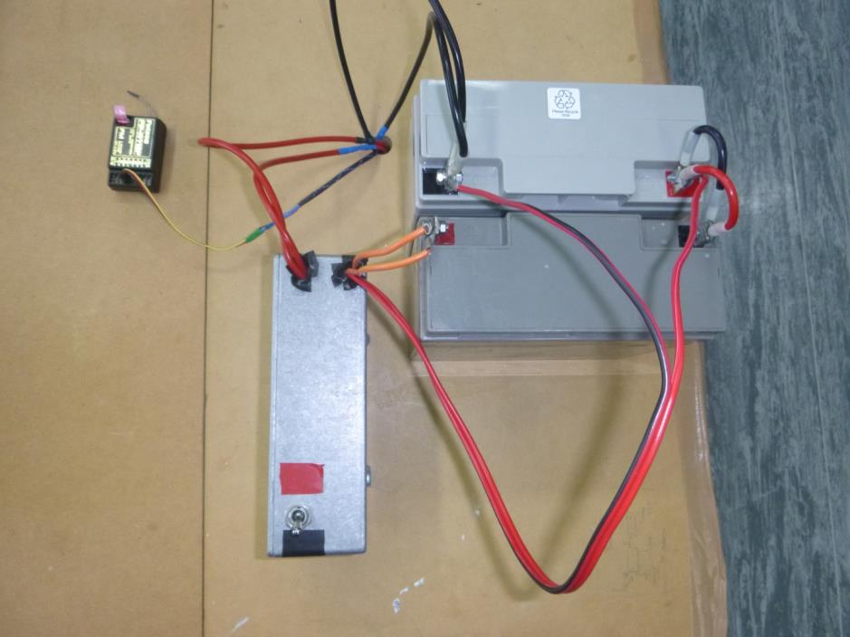

A single control wire is used for both motors. Connect this to the throttle channel of a RC receiver. Alternatively a PWM pulse generator could be used to produce the control signal. This may give finer speed control that an RC transmitter/receiver set.

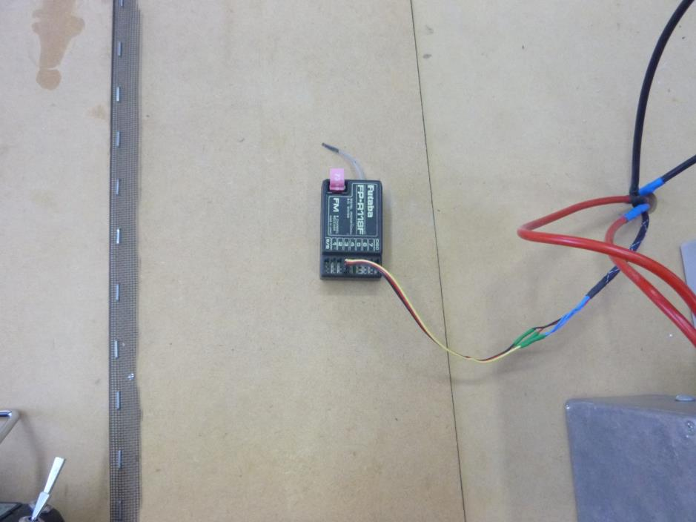

The motor controllers have a ‘BEC’ circuit that back power the receiver, so a separate battery is not required for the receiver. Note that there is a switch inside the tunnel for the ‘BEC’ circuit of each motor controller. Ensure only 1 of these is enabled.

**Operating notes:**

The motors are quite sensitive at lower speeds. This may be able to be combatted by reconfiguring the pulse range for the transmitter or by using a PWM pulse generator.

When run at higher speeds the motor controllers usually overheat after a short time and cut out.